**Volcano VR - HTC Vive**

Udacity VR Developer Nanodegree Term 3 - Capstone

**Albert Lardizabal**

<https://github.com/alardizabal/udacity-vrnd-capstone>

**The Plot**

You're on an island with several volcanoes that are starting to erupt. Your objective is to dodge the lava bombs and survive until dawn.

**The Inspiration**

The idea for the game came from recent news where more parts of Pompeii--the ancient city in Italy buried under lava after a volcano eruption in 79 A.D.--were discovered. I imagined what it would feel like living through the eruption of Mount Vesuvius. I'm very interested in continuing to work on the game after the end of the Udacity program, so given the requirements and time constraints of the Capstone project, I wanted to lay down a foundation that I could build upon in the future. I wanted to use this project as a testbed of ideas to see what would make for a fun game in room-scale VR.

I've played many games on my Vive and I've found that teleportation is the best way to move around a scene without getting nauseous. My vision was of volcanoes around the island erupting and launching lava bombs into the air that the player, who is located in the center of the island, would have to skillfully teleport, dodge, and duck to avoid.

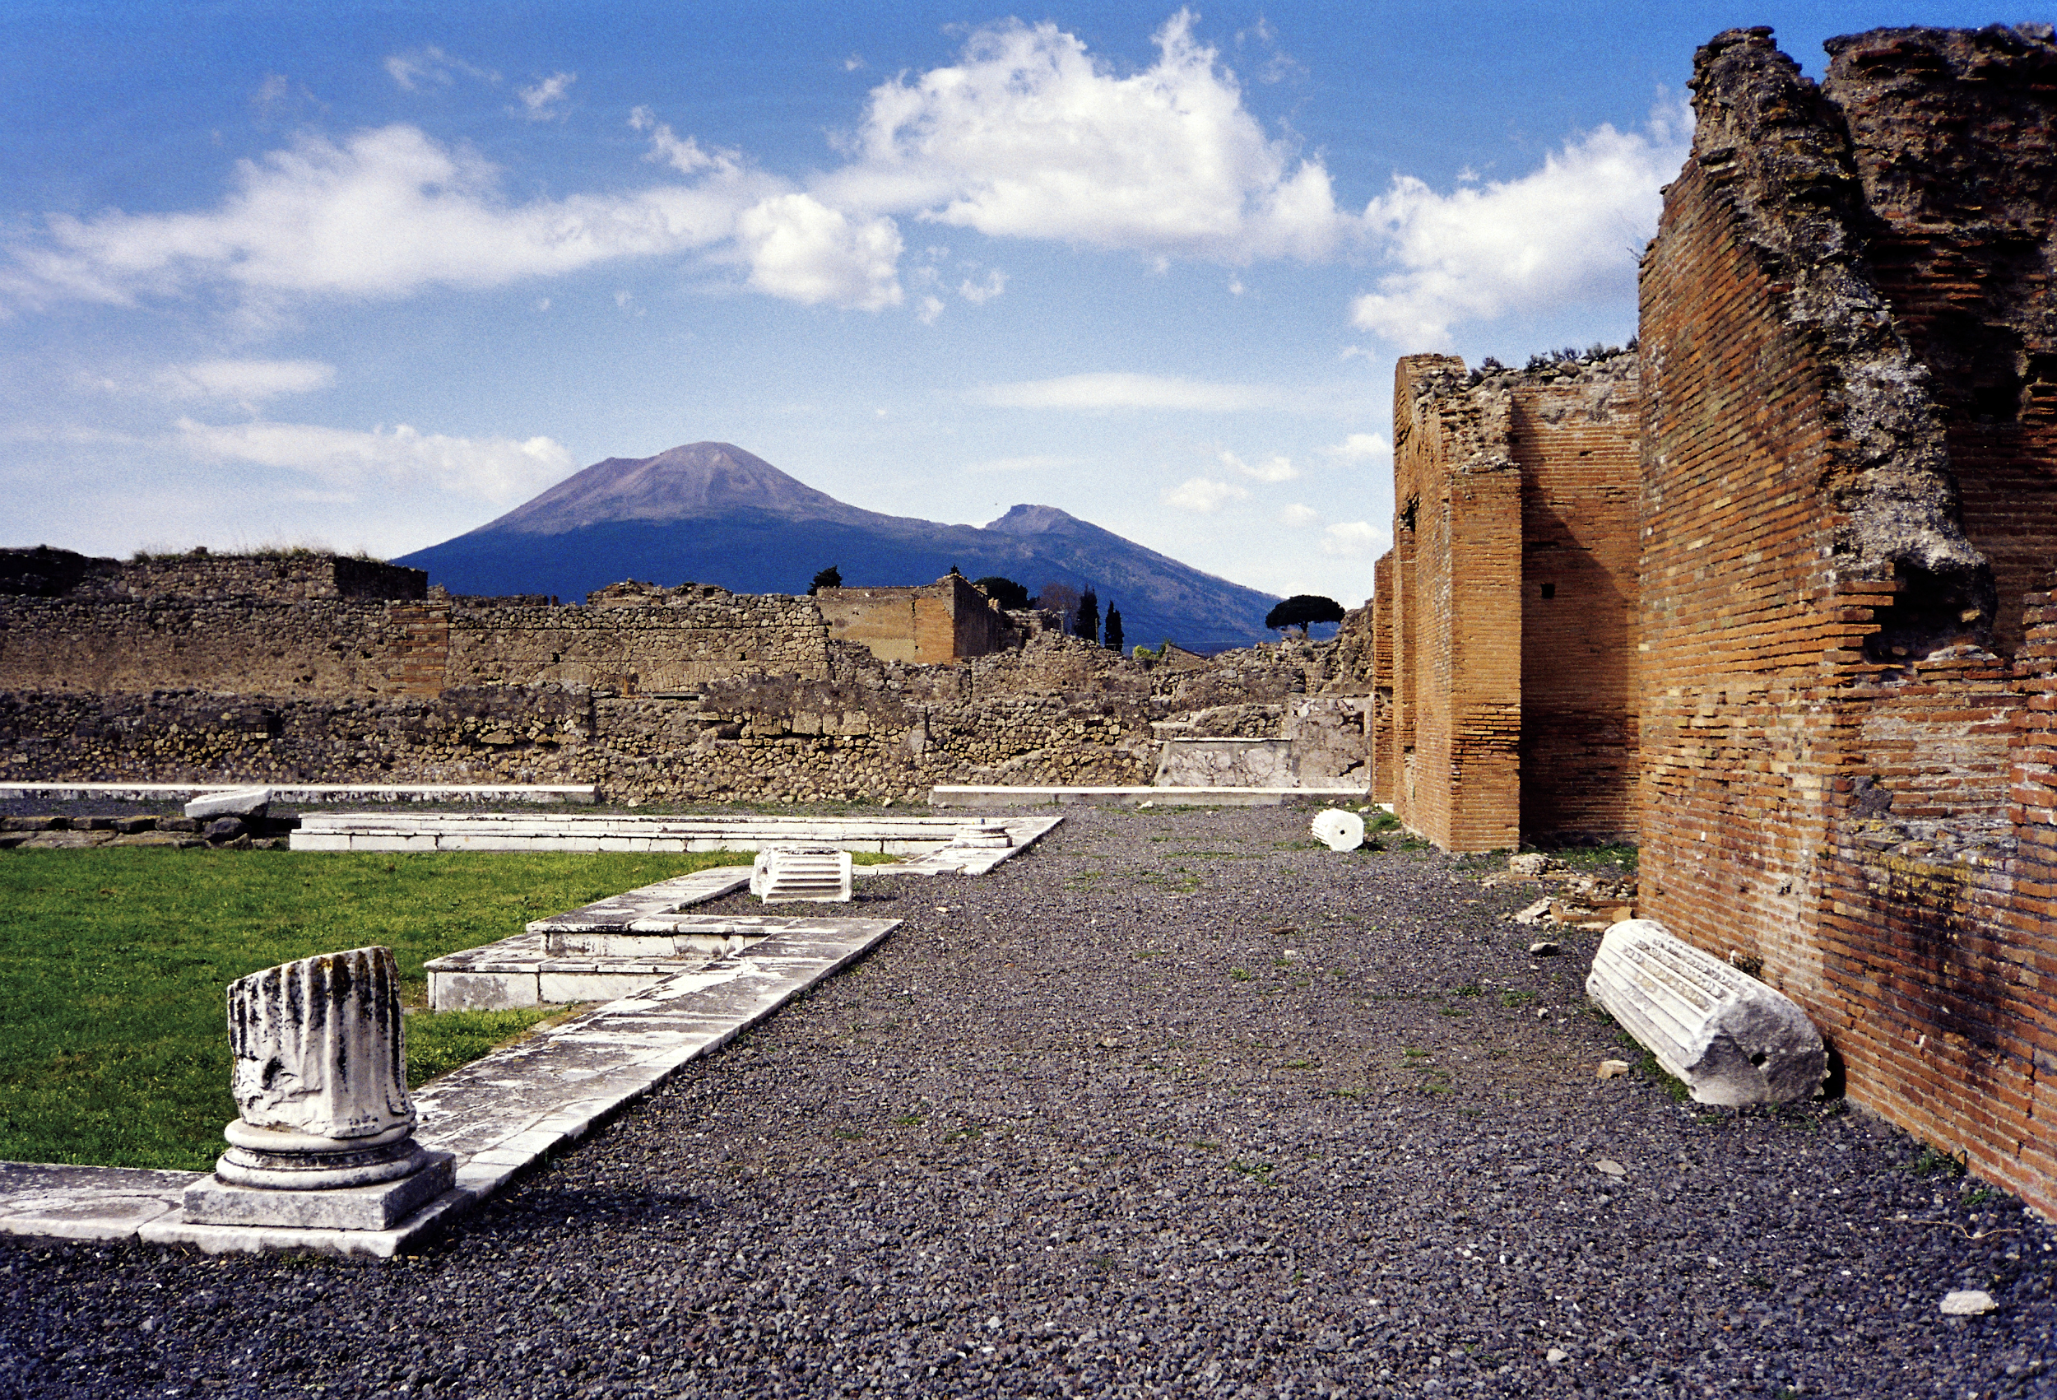

Mt. Vesuvius as seen from Pompeii - [Wikipedia](https://en.wikipedia.org/wiki/Mount_Vesuvius#/media/File:Vesuvius_from_Pompeii_(hires_version_2_scaled).png)

**Emotion - FEAR and SURVIVAL**

I wanted to build an experience that made the player feel a sense of fear and a desire for survival. I want to surround the player with mountains and a large volcano that serves as the antagonist of the game. I considered placing several volcanoes around the island ~~but I think a single volcano gives the impression of player vs. volcano, as if the volcano were the enemy.~~ I ended up making two volcanoes because I wasn’t mathematically adept enough to randomize the lava bomb launch trajectory effectively, so it was initially easy to dodge the falling lava bombs. With two volcanoes, the player has a more challenging time trying to avoid the lava bombs.

I will start the game in the middle of the night. The darkness adds a sense of doom and as the sun rises, the player can stay motivated to survive until the sun rises.

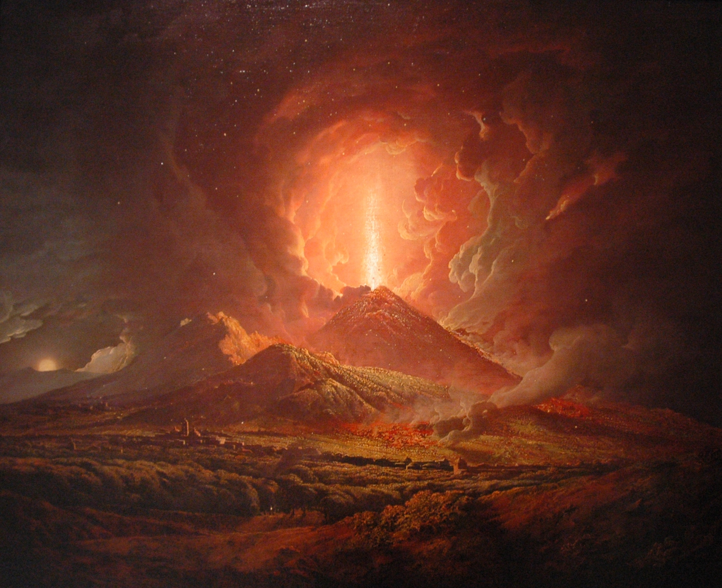

An eruption of Vesuvius seen from Portici, by Joseph Wright (ca. 1774-6)

[Wikipedia](https://en.wikipedia.org/wiki/Vesuvius_in_Eruption_(Wright_painting))

**Gameplay**

* At the start of the game, there will be a narration with instructions on how to play.
* The player must teleport, dodge, and duck to avoid the lava bombs to survive.
* The player must survive for 1 minute.
* The game will begin in darkness in the middle of the night. As time progresses the sun will rise and light the island, marking the player’s survival and winning the game.
* Endings
  + Player wins - Gameplay stops; audio narration announces to the player that they won
  + Player loses - Gameplay stops; audio narration announces to the player that they lost. Level restarts.

**Features**

* Island landscape with volcanoes, a jungle, and some human structures surrounding an open area in the center where the main gameplay happens
* The player will start in the middle of the island. The game starts in the middle of the night and it will be dark except for light emanating from the moon, volcano, pyramid, and lighthouse.
* Spatial sounds will give clues to the player where the volcano and the pyramid are located. Sounds will also give a hint to the user as to where in the air the lava bomb is.
* Speech-to-text using IBM Watson’s HTC Vive plugin to give the user the ability to teleport randomly around the play area to avoid a lava bomb.

**Packages and Dependencies**

* Unity Terrain asset package **OK**
* Unity Standard Assets package **OK**
* Unity Particle Pack **OK**
* Simplistic Low Poly Nature asset package by Acorn Bringer **OK**
* Steam Audio - <https://valvesoftware.github.io/steam-audio/> **OK**
  + This wasn’t mentioned in the course videos but it seems to be pretty easy to use and has a lot of features.
* ~~Watson Speech-to-Text -~~ [~~https://github.com/IBM/vr-speech-sandbox-vive~~](https://github.com/IBM/vr-speech-sandbox-vive)
  + Magic word destroys all active lava bombs
  + Randomly teleport around the play area
  + Menu commands - New game
  + ***Scoping****: I experienced build problems and had some difficulty integrating Speech-to-Text into the project given the time constraints. I plan to try integrating it in the future because it adds an interesting dimension to the game.*
* Steam Level Loader script **OK**

**3D models created using Blender**

* Volcano
  + A conic shape with a crater in the center. **OK**
  + ~~Lava overflowing the sides~~
    - ***Scoping:*** *Wasn’t successful creating good looking lava in Blender. I’ll revisit this in the future.*
  + Smoke and fire particle effects **OK**
* Lava Bombs
  + Sphere with a rough texture **OK**
  + Flames surrounding the lava bomb **OK**
* Pyramid **OK**
* Artifact **OK**
  + This odd looking object was the first mesh I learned to manipulate in blender. It was originally a plain torus, that was then extruded multiple times.
* ~~Lighthouse~~
  + ***Scoping:*** *Ran out of time. The sweeping light that I intended for the lighthouse will instead be placed at the top of the pyramid.*
* Monkey columns **OK**
  + I learned that the monkey head has a special history in Blender, so I envision a classic looking column with a monkey head at the top.
  + ***Scoping:*** *This turned out well. I was getting warnings in Unity about missing UV maps, but figured out how to add them in Blender. I was able to make the columns a little more interesting by adding flames using a Unity asset package.*

**Environment**

* ~~Tiki torches outlining the play area~~
  + ***Scoping:*** *Instead of tiki torches, I added flames to the monkey columns I created.*
* ~~Star field in the night sky~~
  + ***Scoping:*** *I wasn’t sure how to add this properly, but I plan to revisit this in the future because I think a night sky full of stars transitioning away as the sun rose would make the game environment more captivating.*

**Animations**

* Animation of ~~moon setting~~ and sun rising
  + ***Scoping:*** *Ran out of time and wasn’t sure how to properly implement a moon setting/sun rising animation. The sun rising animation was easy to apply to the existing directional light.*

**Lighting**

* ~~Lighthouses~~ will have a light that rotates and casts a light around the island
  + ***Scoping:*** *The sweeping light was adding to the pyramid instead.*
* The sun will animate through the sky as it transitions from night to day **OK**
* ~~Torches~~ will outline the play area and provide illumination to the player during the night.
  + ***Scoping:*** *Adding flames to the monkey head columns gave the play area a better look.*
* I used Unity’s particle pack to make the top of the volcano glow and release smoke.

**Special Effects**

* ~~When a lava bomb hits the ground, a particle effect will be triggered.~~
  + ***Scoping:*** *I ran out of time to perfect this effect while maintaining performant visuals. This will be added in the future.*

**Sounds -** http://www.freesound.org

* Ambient: Volcanoes rumbling
  + ***Scoping:*** *I made the volcano rumbling sound spatialinstead. With the volcano and pyramid on opposite ends of the game play area, the player can get a better sense of where in the play area they are.*
* Spatial: Pyramids (drums), Lava bomb launching, lava bomb flying through the air **OK**
* Birds
  + ***Scoping:*** *I removed this, as I couldn’t figure out a good compromise between many birds making too much noise, or a single bird making a non-spatial noise.*

**Other Audio**

* Instructions to the user **OK**
* Player wins the game **OK**
* Player loses the game **OK**

**Conclusion**

This Capstone was a great project to bring together all of the different things I’ve learned about VR. One of the hardest parts initially was coming up with a good idea for a game. I really liked the volcano idea. In future iterations I could see turning the game into a maze that you have to navigate through, while also under the risk of getting hit by lava bombs. VR’s sense of immersion could make for a very interesting historical experience where the player gets to experience what it feels like to evacuate a city with an erupting volcano hampering your escape. I realized that learning 3D modeling is a very important skill in VR that in addition to producing the required assets for a game, is also a lot of fun. It was easy to get started with Blender, and there were numerous tutorials on Youtube. The final challenge I experienced in the project was finding the right balance between quality and performance in the rendering of the scene.